**O365 Outlook Web Access (OWA)**

* Log into OWA
* Double click the email message, so the message opens in a new window
* With the message open in a new window, click the down arrow on the Reply in upper right of the message and select **View** **Message Details.**

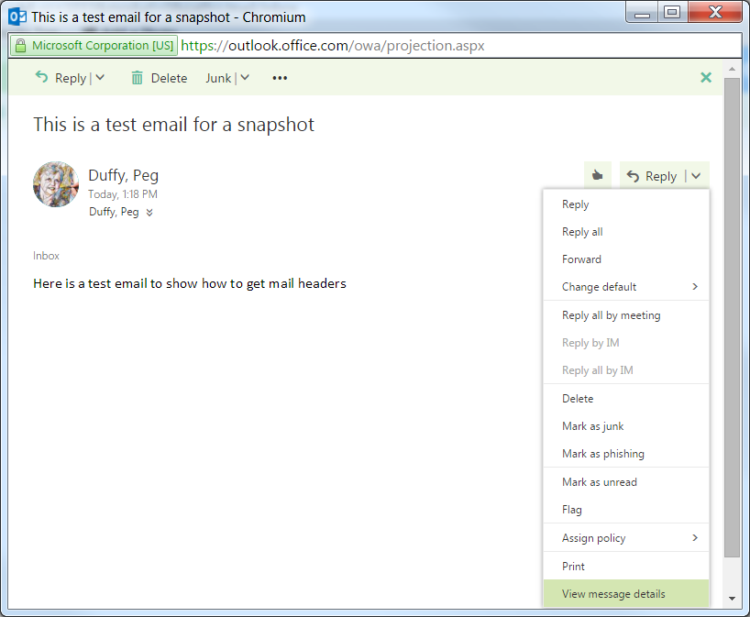

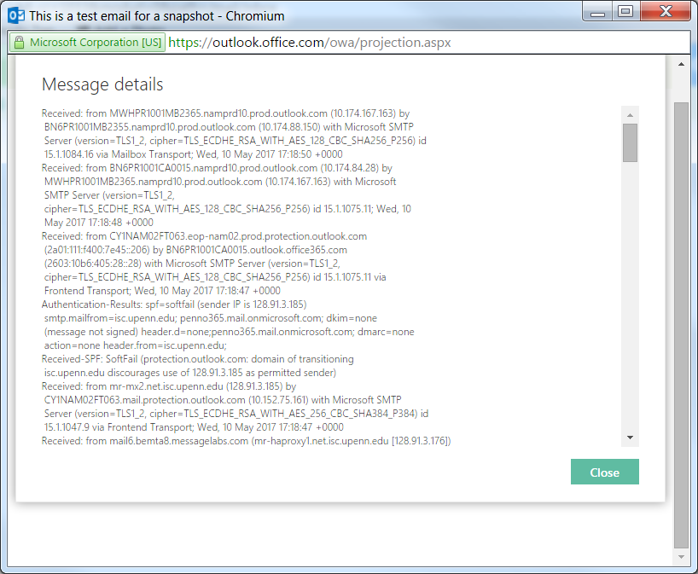

* Header information will appear in a new window, under **Message Details.**
* You can select, copy and paste the text from this window. (make sure to get all of it, note this window is scrollable as message headers are large)

**Outlook for O365**

* Open mailbox.
* Select message. Double click on it.

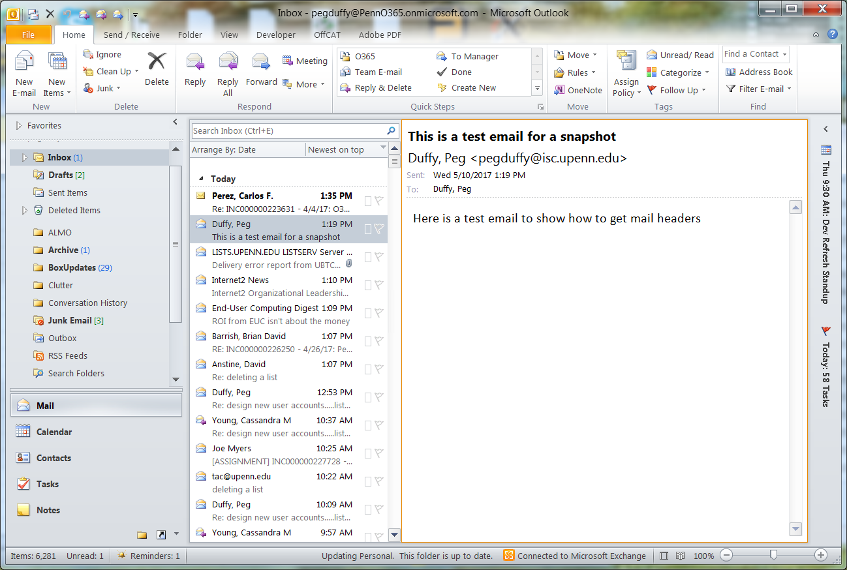

* It will bring message into a new window.
* Click on File tab. (upper Left)

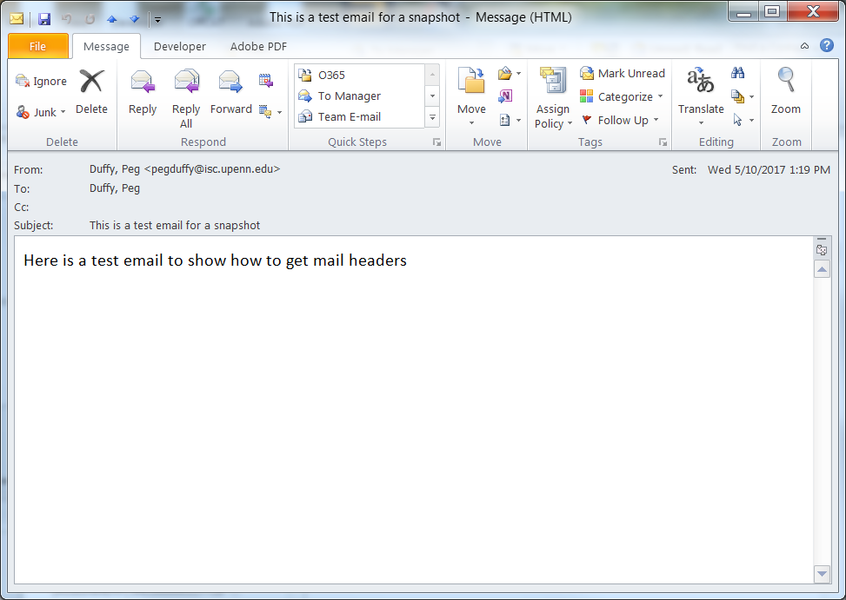

* Select Message Properties.

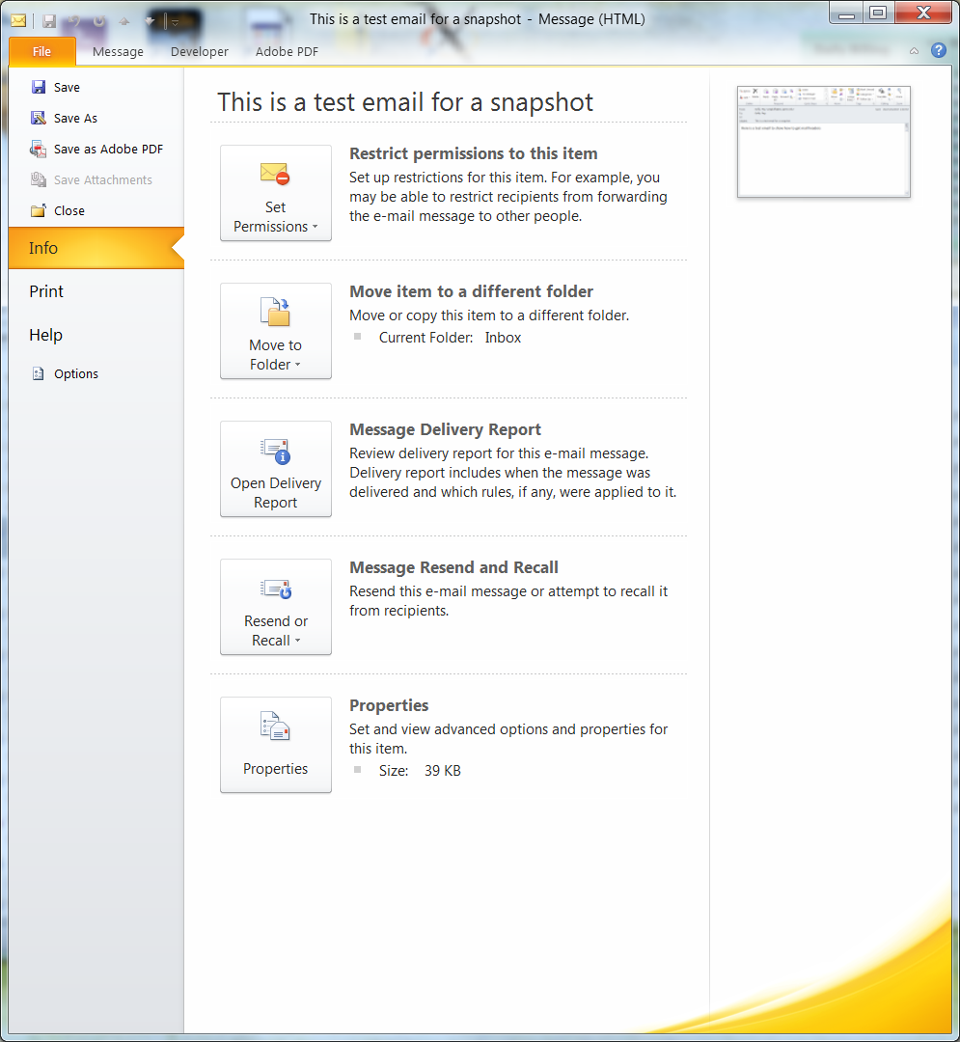

* A new window will pop-up that will contain the message’s Internet Headers.
* Select and copy everything in that text window.

